PLAF MTC - Cockpit Monitor

AS.Simulators

Exported on 2024-10-10 15:29:39

Table of Contents

1 General Information 3

2 Specific requirements 4

3 Cockpit views 6

4 Cockpit Mapping 11

4.1 switches and knobs 67

# General Information

|  |
| --- |
| [**ASIM-50736**](https://jira.esl.corp.elbit.co.il/browse/ASIM-50736)  The Cockpit Controls component shall be composed of two sections - cockpit graphics and cockpit logger. |

|  |
| --- |
| [**ASIM-50737**](https://jira.esl.corp.elbit.co.il/browse/ASIM-50737)  The cockpit graphics component shall include a full cockpit figure along with a five-section view:  Instrument panel  Left auxiliary  Left console  Right auxiliary  Right console  There shall be stick and throttle figures along with stick movement and throttle movement indicators (see the following figures). |

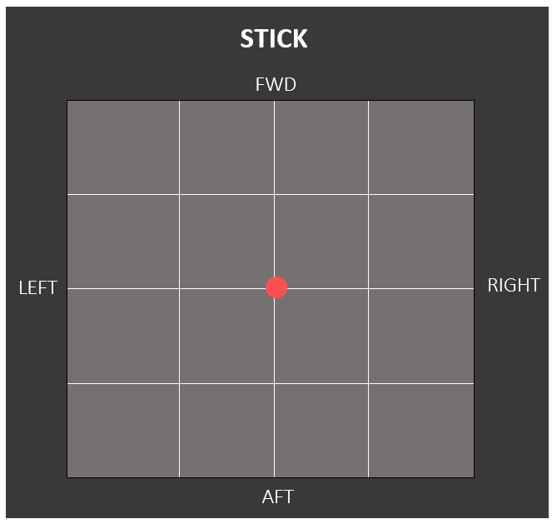  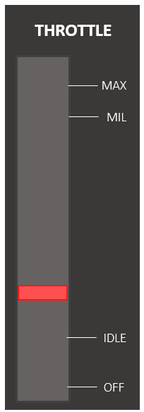

# Specific requirements

|  |
| --- |
| [**ASIM-50739**](https://jira.esl.corp.elbit.co.il/browse/ASIM-50739)  The user shall be able to select consoles to present |

|  |
| --- |
| [**ASIM-50741**](https://jira.esl.corp.elbit.co.il/browse/ASIM-50741)  The user shall be able to expend / narrow a selected console |

|  |
| --- |
| [**ASIM-50742**](https://jira.esl.corp.elbit.co.il/browse/ASIM-50742)  Upon Expending/narrowing a console, the panel proportions shall remain the same |

|  |
| --- |
| [**ASIM-50743**](https://jira.esl.corp.elbit.co.il/browse/ASIM-50743)  Every movement in the cockpit shall be indicated with a frame (see the following figure) |

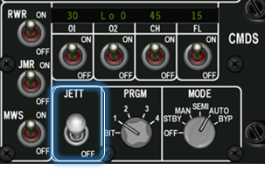

|  |
| --- |
| [**ASIM-50744**](https://jira.esl.corp.elbit.co.il/browse/ASIM-50744)  All the control components and the DED shall represent their actual state in the cockpit |

|  |
| --- |
| [**ASIM-50745**](https://jira.esl.corp.elbit.co.il/browse/ASIM-50745)  The user shall be able to move a console by long pressing and moving it |

|  |
| --- |
| [**ASIM-50746**](https://jira.esl.corp.elbit.co.il/browse/ASIM-50746)  Pressing a console in the cockpit's image shall expend it |

|  |
| --- |
| **Issue unavailable** All the display screens in the cockpit, besides the DED and PFLD screens, shall be blank |

|  |
| --- |
| **Issue unavailable**  The DED and PFLD display shall support the following characters: |

# Cockpit views

Full cockpit

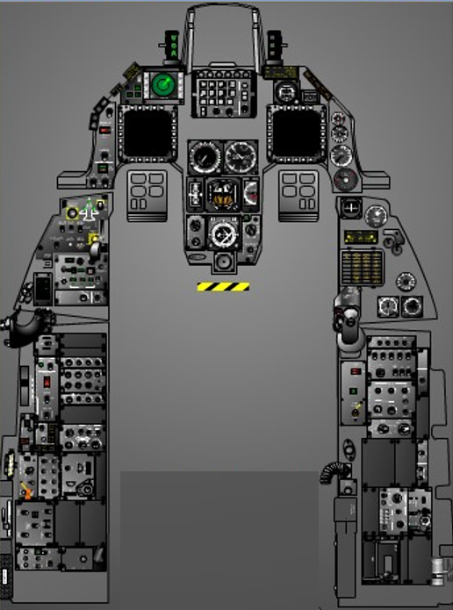

Instrument panel

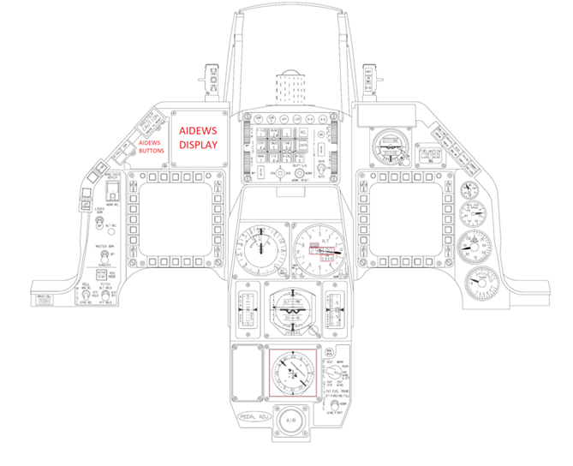 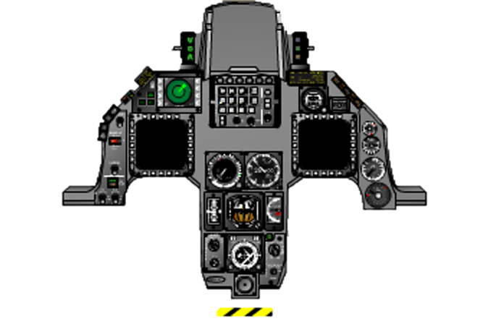

Right auxiliary + console

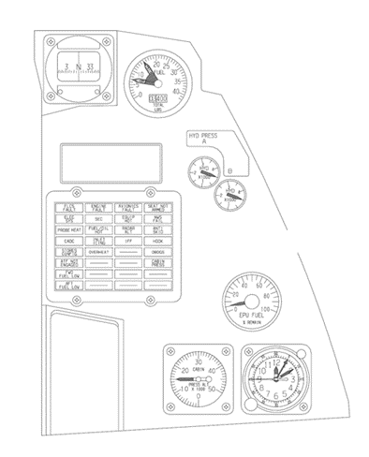 (auxiliary)

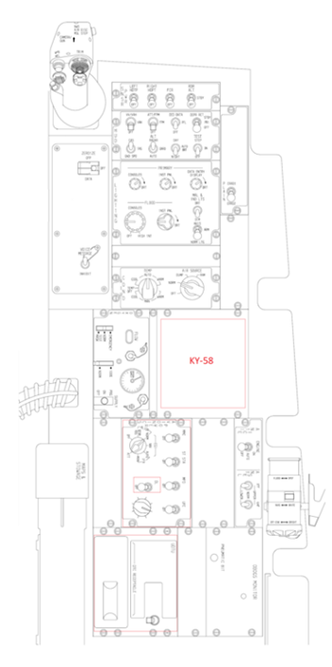 (console)

Left auxiliary +console

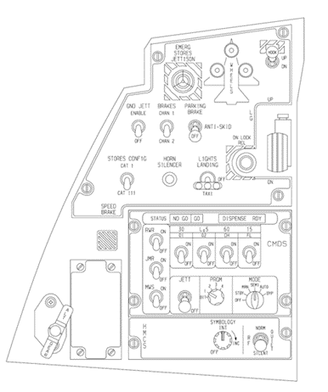 (auxiliary)

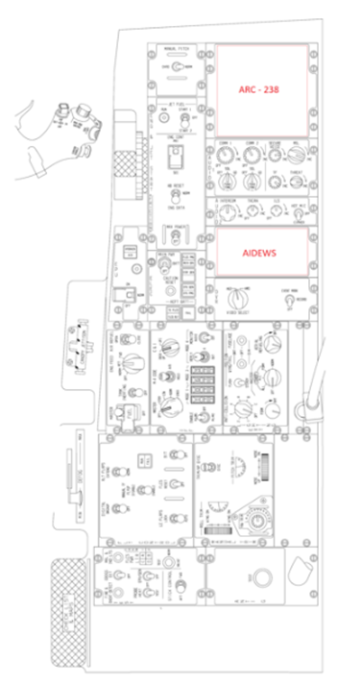 (console)

The HUD will not be presented as a part of the cockpit view.

|  |
| --- |
| [**ASIM-50747**](https://jira.esl.corp.elbit.co.il/browse/ASIM-50747)  The "log" column in the table below describes the actions that shall be noted in the logger |

# Cockpit Mapping

|  |  |  |  |  |  |
| --- | --- | --- | --- | --- | --- |
| name | description | log | mark | picture | owner required |
| **ICP**   * Integrated control panel |  |  |  |  |  |
| Com 1 override button | Pressed/not pressed |  |  |  |  |
| Com 2 override button | Pressed/not pressed |  |  |  |  |
| IFF override button | Pressed/not pressed |  |  |  |  |
| ENTER button | Pressed/not pressed |  |  |  |  |
| M-SEL button (0 key) | Pressed/not pressed |  |  |  |  |
| DRIFT C/O switch | Drift c/o  Norm  Warn reset |  | √ |  | X |
| Data control switch (DCS) | Up/down/left (RTN)/right (SEQ) |  |  |  |  |
| Increment/ Decrement switch | Pressed up/ pressed down/ not pressed |  |  |  |  |
| LIST button | Pressed/not pressed |  |  |  |  |
| A-A button | Pressed/not pressed | Master mode:   A-A |  |  |  |
| A-G button | Pressed/not pressed | Master mode:  A-G |  |  |  |
| RCL button | Pressed/not pressed |  |  |  |  |
| RET DEPER knob | Moved/ not moved |  |  |  | X |
| CONT knob (not used) | Moved/ not moved |  |  |  |  |
| SYM knob | Moved/ not moved |  |  |  |  |
| BRT knob (not used) | Moved/ not moved |  |  |  |  |
| Weather mode button (not used) | Pressed/not pressed |  |  |  |  |
| FLIR Increment /Decrement (not used) | Pressed up/ pressed down/ not pressed |  |  |  |  |
| FLIR gain switch | Gain/LVL/  Auto |  |  |  | X |
| Priority function and numeric keyboard | | | | |  |
| T-ILS/ key 1 | Pressed/not pressed |  |  |  |  |
| ALOW/ key 2 | Pressed/not pressed |  |  |  |  |
| Key 3 | Pressed/not pressed |  |  |  |  |
| STPT/ key 4 | Pressed/not pressed |  |  |  |  |
| CRUS/ key 5 | Pressed/not pressed |  |  |  |  |
| TIME/ key 6 | Pressed/not pressed |  |  |  |  |
| MARK/ key 7 | Pressed/not pressed |  |  |  |  |
| FIX/ key 8 | Pressed/not pressed |  |  |  |  |
| A-CAL/ key 9 | Pressed/not pressed |  |  |  |  |
| DED   * Instrument panel | display screening |  |  |  |  |
| **AOA indexer**   * Instrument panel |  |  |  |  | X |
| High AOA indexer (above 15) | Illuminated/ not illuminated |  |  |  | X |
| Optimum AOA indexer (approximately 13) | Illuminated/ not illuminated |  |  |  | X |
| Low AOA indexer (under 11) | Illuminated/ not illuminated |  |  |  | X |
| **AR status + NWS indicator**   * Instrument panel |  |  |  |  |  |
| RDY status light | Illuminated/ not illuminated |  |  |  |  |
| AR NWS status light | Illuminated/ not illuminated |  |  |  |  |
| DISC status light | Illuminated/ not illuminated |  |  |  |  |
| DEWD  (Dedicated Electronic Warfare Display)   * Instrument panel | display |  |  |  |  |
| DEWD BRT knob | Moved/ not moved |  |  |  |  |
| Airspeed/Mach indicator   * Instrument panel |  |  |  |  | X |
| Airspeed/Mach IND set index knob |  |  |  |  |  |
| **HSI (display)**   * Instrument panel |  |  |  |  |  |
| Course indication |  |  |  |  |  |
| Range indicator |  |  |  |  |  |
| Range indicator warning flag | Show/hide |  |  |  |  |
| CRS set knob | Moved/ not moved |  |  |  |  |
| HDG set knob | Moved/ not moved |  |  |  |  |
| Instrument mode selector | pressed/ not pressed |  |  |  |  |
| Instrument mode indicator |  |  |  |  |  |
| Course Deviation Warning Flag | Show/hide |  |  |  |  |
| INU Invalid Flag or ATT Failure Flag | Show/hide |  |  |  |  |
| Altimeter (display)   * Instrument panel |  |  |  |  |  |
| barometric setting knob | Moved/ not moved |  |  |  |  |
| Altimeter mode switch | STBY/ Norm |  |  | instead of PNEU it needs to be **STBY**  instead of ELECT it needs to be **NORM** |  |
| PNEU / STBY flag | Show PNEU/ show STBY/ hide |  |  | (yellow) |  |
| Rudder PEDAL ADJ Knob   * Instrument panel |  |  |  |  |  |
| Vertical velocity indicator   * Instrument panel |  |  |  |  | X |
| AOA indicator   * Instrument panel |  |  |  |  | X |
| Fuel flow indicator   * Instrument panel |  |  |  |  | X |
| Oil pressure indicator   * Instrument panel |  |  |  |  | X |
| NOZ POZ indicator   * Instrument panel |  |  |  |  | X |
| RPM indicator   * Instrument panel |  |  |  |  | X |
| FTIT indicator   * Instrument panel |  |  |  |  | X |
| Standby Attitude Indicator   * Instrument panel |  |  |  |  | X |
| Pull to cage knob | Moved/ not moved |  |  |  | X |
| **Fuel QTY SEL**   * Instrument panel |  |  |  |  |  |
| Fuel QTY SEL selector | TEST/ NORM / RSVR / INT WING & CFT / INT WING / EXT WING / EXT CTR | Fuel QTY SEL:  TEST/ NORM / RSVR / INT WING & CFT / INT WING / EXT WING / EXT CTR | √ |  |  |
| EXT FUEL TRANS switch | CFT FIRST (NO FILL) / NORM / WING FIRST | EXT FUEL TRANS: CFT FIRST (NO FILL) / NORM / WING FIRST | √ |  |  |
| **ADI**   * Instrument panel |  |  |  |  |  |
| GS flag | Show flag/  Hide flag |  |  |  |  |
| LOC flag | Show flag/  Hide flag |  |  |  |  |
| OFF flag | Show flag/  Hide flag |  |  |  |  |
| AUX flag | Show flag/  Hide flag |  |  |  |  |
| Pitch Trim Knob | moved/ not moved |  |  |  |  |
| **Left glare shield**   * Instrument panel |  |  |  |  | X |
| MASTER CAUTION light | Illuminated  Not illuminated |  |  |  | X |
| MASTER CAUTION button | Pressed/not pressed |  | √ |  | X |
| ECM light | Illuminated/  Not illuminated |  |  |  | ECM Model |
| TF FAIL light | Illuminated/  Not illuminated |  |  |  | X |
| **MFDs (L/R)**   * Instrument panel | Blank - the content of the MFD screen doesn't need to be displayed in the cockpit monitor |  |  |  |  |
| Symbology rocker switch | Pressed/not pressed |  |  |  |  |
| Contrast rocker switch | Pressed/not pressed |  |  |  |  |
| Brightness rocker switch | Pressed/not pressed |  |  |  |  |
| Gain rocker switch | Pressed/not pressed |  |  |  |  |
| OSB 1 | Pressed/not pressed |  |  |  |  |
| OSB 2 | Pressed/not pressed |  |  |  |  |
| OSB 3 | Pressed/not pressed |  |  |  |  |
| OSB 4 | Pressed/not pressed |  |  |  |  |
| OSB 5 | Pressed/not pressed |  |  |  |  |
| OSB 6 | Pressed/not pressed |  |  |  |  |
| OSB 7 | Pressed/not pressed |  |  |  |  |
| OSB 8 | Pressed/not pressed |  |  |  |  |
| OSB 9 | Pressed/not pressed |  |  |  |  |
| OSB 10 | Pressed/not pressed |  |  |  |  |
| OSB 11 | Pressed/not pressed |  |  |  |  |
| OSB 12 | Pressed/not pressed |  |  |  |  |
| OSB 13 | Pressed/not pressed |  |  |  |  |
| OSB 14 | Pressed/not pressed |  |  |  |  |
| OSB 15 | Pressed/not pressed |  |  |  |  |
| OSB 16 | Pressed/not pressed |  |  |  |  |
| OSB 17 | Pressed/not pressed |  |  |  |  |
| OSB 18 | Pressed/not pressed |  |  |  |  |
| OSB 19 | Pressed/not pressed |  |  |  |  |
| OSB 20 | Pressed/not pressed |  |  |  |  |
| MRK BCN Light   * Instrument panel | illuminated/ mot illuminated |  |  | illuminated green | NAVAIDs  Model |
| **MISC panel**   * Instrument panel |  |  |  |  | X |
| DRAG CHUTE guard | Open/closed |  |  |  | X |
| DRAG CHUTE switch | Deploy  NORM/REL | Drag chute: deploy  Drag chute: REL | √ |  | X |
| LASER ARM switch | Arm/off |  | √ |  |  |
| ALT REL button | Pressed/ not pressed |  | √ |  | X |
| MASTER ARM switch | Master arm/ off/ simulate | MASTER ARM: ARMOFF/SIM | √ |  | X |
| ADV MODE Switch | Pressed/ not pressed |  | √ |  | X |
| Autopilot pitch switch | ALT HOLD  A/P OFF  ATT HOLD | Autopilot pitch:  ALT HOLD  A/P OFF  ATT HOLD | √ |  | X |
| Autopilot roll switch | HDG SEL  ATT HOLD  STRG SEL | Autopilot roll:  HDG SEL  ATT HOLD  STRG SEL | √ |  | X |
| **AIDEWS auxiliary pane**   * Instrument panel |  |  |  |  |  |
| ML mute button | Pressed/ not pressed |  | √ |  |  |
| 0-5 Priority button | Pressed/ not pressed |  | √ |  |  |
| 0-5 Priority light | Illuminated/ not illuminated |  |  |  |  |
| ALL Priority button light | Pressed/ not pressed |  | √ |  |  |
| ALL Priority light | Illuminated/ not illuminated |  |  |  |  |
| BIT button | Pressed/ not pressed |  | √ |  |  |
| Go light | Illuminated/ not illuminated |  |  | green |  |
| No go light | Illuminated/ not illuminated |  |  | red |  |
| ONBD TRNG switch | Pressed/ not pressed  (Press and hold to activate press again to deselect) |  | √ |  |  |
| ONBD TRNG light | Illuminated/ not illuminated |  |  | yellow |  |
| OV TEMP light | Illuminated/  Not illuminated |  |  | red |  |
| F-ACK   * Instrument panel | Pressed/ not pressed |  | √ |  | X |
| IFF IDENT   * Instrument panel | Pressed/ not pressed |  | √ |  | IFF |
| Magnetic compass   * Right auxiliary |  |  |  |  | X |
| Fuel quantity indicator   * Right auxiliary |  |  |  |  | Fuel Model |
| PFL display   * Right auxiliary |  |  |  |  |  |
| System A HYD PRESS Indicator   * Right auxiliary |  |  |  |  | X |
| System B HYD PRESS Indicator   * Right auxiliary |  |  |  |  | X |
| EPU fuel quantity indicator   * Right auxiliary |  |  |  |  | X |
| CABIN PRESS altimeter   * Right auxiliary |  |  |  |  | X |
| clock   * Right auxiliary |  |  |  |  | X |
| **LG control panel**   * Left auxiliary |  |  |  |  | X |
| HOOK switch | Up/down | HOOK: up/ down | √ |  | X |
| DN LOCK REL button | Pressed/ not pressed |  | √ |  | X |
| EMER STORES JETTISON frangible cover | Open/closed |  |  |  | SMS - Jettison |
| EMER STORES JETTISON (PANIC) button | Pressed/ not pressed | PANIC: pressed | √ |  | SMS - Jettison |
| ANTI SKID switch | Parking brake/ anti-skid/ off | ANTI-SKID: parking/ anti-skid /off | √ |  | X |
| BRAKES CHANNEL switch | CHAN 1 / CHAN 2 | BRAKES: CHAN 1 / CHAN 2 | √ |  | X |
| GROUND JETT switch | Enable/off | GND JETT: enable/off | √ |  | X |
| Stores config switch | CAT 1 / CAT 3 | STORES CONFIG: CAT 1 / CAT 3 | √ |  |  |
| Horn silencer button | Pressed/ not pressed |  | √ |  | VMU Model |
| Lights switch | Landing/taxi/  off |  | √ |  | X |
| R wheel light | Illuminated/  Not illuminated |  |  |  | X |
| L wheel light | Illuminated/  Not illuminated |  |  |  | X |
| Nose wheel light | Illuminated/  Not illuminated |  |  |  | X |
| Landing gear handle | Up/down | LG handle: Up / Down | √ |  | X |
| Landing gear handle light | Illuminated/  Not illuminated |  |  |  | X |
| LG Handle Down Permission Button | Pressed/ not pressed |  | √ |  | X |
| Speed break indicator | Closed/ dots pattern/ lines pattern - Diagonals (no power) |  |  | No power  fully closed  deployed | X |
| **CHAFF/FLARE dispense button** | Pressed/ not pressed |  |  | (On the right sidewall above the throttle) |  |
| **CMDS control panel**   * Left auxiliary |  |  |  |  |  |
| System status display | NO GO / GO  (display) |  |  |  |  |
| DISPENSE/RDY display | Dispense/ RDY  (display) |  |  |  |  |
| RWR switch | On/off |  | √ |  |  |
| JMR switch | On/off |  | √ |  |  |
| MWS switch | On/off |  | √ |  |  |
| Inventory display |  |  |  |  |  |
| 01 switch | On/off |  | √ |  |  |
| 02 switch | On/off |  | √ |  |  |
| CHAFF switch | On/off |  | √ |  |  |
| FLARE switch | On/off |  | √ |  |  |
| JETT switch | On/off | Flares JETT: ON | √ |  |  |
| PRGM selector | BIT/1/2/3/4 |  | √ |  |  |
| MODE selector | Off/stby/ man/semi/ auto/ byp |  | √ |  |  |
| **ALT GEAR**   * Left auxiliary |  |  |  |  | X |
| Alt gear handle | Pulled/ not pulled | Alt Gear Handle: pulled/ not pulled | √ | pulled | X |
| Alt gear reset button | Pressed/ not pressed |  | √ |  | X |
| **HMCS panel**   * Left auxiliary |  |  |  |  |  |
| Symbology int knob | Moved/ not moved (OFF to INC) |  |  |  |  |
| RF switch | Norm/quiet/ silent |  | √ |  | X |
| **Stick** |  |  |  |  | X |
| NWS A/R DISC MSL STEP button | Pressed/ not pressed |  |  |  | X |
| Trim button | Fwd/aft/left/  right |  |  |  | X |
| Display management switch (DMS) | Fwd/aft/left/  right |  |  |  | X |
| Target management switch (TMS) | Fwd/aft/left/  right |  |  |  | X |
| Countermeasures management switch (CMS) | Fwd/aft/left/  right |  |  |  | X |
| Expand/FOV Button | Pressed/ not pressed |  |  | No need to show on graphics | X |
| Paddle switch | Pressed/ not pressed |  |  | No need to show on graphics | X |
| Camera/gun trigger | Pressed/ not pressed |  |  |  | X |
| WPN REL button | Pressed/ not pressed | WPN REL: pressed |  |  | X |
| **Throttle** |  |  |  |  | X |
| Throttle cutoff release | Pressed/ not pressed |  |  |  | X |
| COMM transmit switch | Fwd/aft/left/  Right (momentary) |  |  |  | X |
| MAN RNG/ uncage knob/switch | Pressed/ not pressed  Rotated/ not rotated |  |  |  | X |
| ANT ELEV knob | Rotated/ not rotated |  |  |  | X |
| Dogfight switch | Dogfight (outboard)/ center/ Missile override (inboard) | DGFT: Dogfight/  Missile OVRD |  |  | X |
| SPEED BREAK switch | Open (aft) momentary/ center/ close (forward) | SPD BRK: open/ close |  |  | X |
| RDR CURSOR/ ENABLE switch | Pressed/ not pressed |  |  |  | X |
| Throttle movement | THROTTLE: Idle (mil or off to idle)  THROTTLE: Off (to off)  THROTTLE: Mil (AB or idle to mil)  THROTTLE: AB (to AB) | THROTTLE: Idle (mil or off to idle)  THROTTLE: Off (to off)  THROTTLE: Mil (AB or idle to mil)  THROTTLE: AB (to AB) |  | No need for graphics - log indication only | X |
| **SNSR PWR panel**   * Right console |  |  |  |  |  |
| L HDTP switch | On/off | L HDTP: on/off | √ |  | X |
| R HDTP switch | On/off | R HDTP: on/off | √ |  | X |
| FCR switch | On/off | FCR: on/off | √ |  | X |
| RDR ALT switch | On/stby/off | RDR ALT:  on/stby/ off | √ |  | X |
| **HUD control panel**   * Right console |  |  |  |  | HUD Model |
| Scales switch | VV/VAH  VAH / OFF |  | √ |  |  |
| FPM switch | ATT/FPM  FPM / OFF |  | √ |  |  |
| DAD DATA switch | DED data/ PFL /off |  | √ |  |  |
| DEPR RET switch | STBY/PRI/OFF |  | √ |  |  |
| Velocity switch | CAS/TAS/ GND SPEED | Velocity: GND Speed/ CAS/ TAS | √ |  |  |
| ALT switch | RADAR/BARO/ Auto | ALT: Radar/ BARO/ auto | √ |  |  |
| Brightness control switch | Day/Auto/ Night |  | √ |  |  |
| TEST switch | Step/On/Off |  | √ |  |  |
| PLAIN cipher switch   * Right console | Card 1/ Card 2 |  | √ |  | X |
| ZEROIZE guard   * Right console | Open/closed |  |  |  |  |
| ZEROIZE switch | OFP/OFF/ DATA | ZEROIZE:  OFP/OFF/ DATA | √ |  | X |
| Voice massage switch   * Right console | Voice message/ Inhibit |  | √ |  |  |
| **Interior lighting**   * Right console |  |  |  |  |  |
| Primary consoles Knob | Moved/ not moved |  | √ |  | X |
| Primary INST PNL Knob | Moved/ not moved |  | √ |  | X |
| Data entry display Knob | Moved/ not moved |  | √ |  | X |
| MAL & IND LTS Intensity Switch | BRT/ DIM |  | √ |  | X |
| Flood INST PNL Knob | Moved/ not moved |  | √ |  | X |
| Flood consoles Knob | Moved/ not moved (Off to high INT) |  | √ |  | X |
| NVIS Switch | NVIS/ARM/ Norm LTG |  | √ |  | X |
| **AIR COND panel**   * Right console |  |  |  |  |  |
| TEMP selector | Off/cool/ auto/warm | TEMP: Off/cool/ auto/warm | √ |  | X |
| AIR SOURCE selector | Off/norm/ dump/ram | AIR SOURCE: off/norm/ dump/ram | √ |  | X |
| **Oxygen panel**   * Right console |  |  |  |  |  |
| Oxygen flow indicator | Black/white |  |  |  | X |
| Oxygen supply indicator |  |  |  |  |  |
| Supply mode lever | PBG/on/off |  | √ | SUPPLY | X |
| Duliter lever | Norm/100% | OXY Duliter: norm/ 100% | √ |  | X |
| Emergency lever | Norm/ emergency/ test mask | OXY Emergency:  Norm/ emergency/ test mask | √ |  | X |
| **ANT SEL**   * Right console |  |  |  |  |  |
| ANT SEL IFF switch | Upper/norm/ lower |  | √ |  | X |
| ANT SEL UHF switch | Upper/norm/ lower |  | √ |  | X |
| Anti Ice   * Right console | On/auto/off | ANTI ICE: on/auto/ off | √ |  | X |
| **Avionics power panel**   * Right console |  |  |  |  |  |
| MMC switch | MMC (on)/ off | MMC: MMC (on)/ off | √ |  |  |
| ST STA switch | ST STA (on)/ off | ST STA: ST STA (on)/ off | √ |  |  |
| MFD switch | MFD (on)/ off | MFD: MFD (on)/ off | √ |  |  |
| UFC switch | UFC (on)/ off | UFC: UFC (on)/ off | √ |  |  |
| EGI knob | OFF/ STOR HDG/ NORM/ NAV/ ALIGN/ ATT | EGI: OFF/ STOR HDG/ NORM/ NAV/ ALIGN/ ATT | √ |  |  |
| GPS switch | GPS (on)/ off | GPS: GPS (on)/ off | √ |  | X |
| DL switch | DL (on)/ off | DL: DL (on)/ off | √ |  | X |
| MIDS LVT knob | Zero/off/on |  | √ |  | X |
| **K-58 (Secure voice control) panel**   * Right console |  |  |  |  |  |
| Mode knob | P/C/LD/RV |  | √ |  | X |
| Fill knob | Z 1-5/ 1/2/3/ 4/5/6/ Z ALL |  | √ |  | X |
| Power Knob | TD/ON/OFF |  | √ |  | X |
| Volume knob | Moved/not moved |  |  |  | X |
| Scratchpad |  |  |  |  |  |
| Fill port |  |  |  |  |  |
| Manual pitch override (MPO)   * Left console | Norm/OVRD  Spring-loaded to norm | MPO: Norm/ OVRD | √ |  | X |
| **Radio backup control panel**   * Left console |  |  |  |  |  |
| Display |  |  |  |  | ? |
| Keypad | Each key – pressed/ not pressed |  |  |  | ? |
| Squelch/ Acknowledge Switch | OFF/SQL/  ACKN |  | √ |  | ? |
| Take button | Pressed/ not pressed |  | √ |  | ? |
| Mode knob | ZERO/OFF/TR/TR+G/ADF/ GD/SET |  | √ |  | ? |
| Volume knob | Moved/ not moved |  |  |  | ? |
| SQL Led indicator | Illuminated/  Not illuminated |  |  |  | ? |
| OR Led indicator | Illuminated/  Not illuminated |  |  |  | ? |
| GO Led indicator | Illuminated/  Not illuminated |  |  |  | ? |
| TX Led indicator | Illuminated/  Not illuminated |  |  |  | ? |
| FILL Port (connector) |  |  |  |  |  |
| **AUDIO 1 control panel**   * Left console |  |  |  |  |  |
| COMM 1 knob | Moved/ not moved |  | √ |  |  |
| COMM 2 knob | Moved/ not moved |  | √ |  |  |
| Secure voice knob | Moved/ not moved |  | √ |  |  |
| MSL knob | Moved/ not moved |  | √ |  |  |
| Comm 1 SQL selector | OFF/SQL/GD | COMM 1:  OFF/SQL/ GD | √ |  |  |
| Comm 2 SQL selector | OFF/SQL/GD | COMM 2:  OFF/SQL/ GD | √ |  |  |
| TF knob | Moved/ not moved |  | √ |  | X |
| Threat knob | Moved/ not moved |  | √ |  | X |
| **AUDIO 2 control panel**   * Left console |  |  |  |  |  |
| Intercom knob | Moved/ not moved |  | √ |  | X |
| TACAN knob | Moved/ not moved |  | √ |  | X |
| ILS knob | Moved/ not moved/ off |  | √ |  | X |
| Hot mic switch | Hot mic/off/  cipher |  | √ |  | X |
| **ENG & JET start control panel**   * Left console |  |  |  |  |  |
| JFS RUN light | Illuminated/ not illuminated |  |  |  |  |
| JFS start switch | Start 1/off/ start 2 | JFS: Start 1 /off/start 2 | √ |  | X |
| ENG CONT guard | Opened/ closed |  |  |  | X |
| ENG CONT switch | SEC/PRI | ENG CONT: SEC/ PRI | √ |  | X |
| AB RESET switch | AB reset/ norm/ ENG data | AB RESET: AB reset/ norm/ ENG data | √ |  | X |
| MAX POWER switch | Max power/ off | MAX POWER: max power/ off | √ | **MAX POWER** instead of COMBAT  **OFF** instead of NORMAL | X |
| **AIDEWS primary control panel**   * Left console |  |  |  |  |  |
| Record button | Pressed/ not pressed |  | √ |  |  |
| Rec label light | Illuminated green/ illuminated yellow/ not illuminated |  |  | (illuminated green/yellow) |  |
| Full label light | Illuminated (red)/ not illuminated |  |  | (illuminated red) |  |
| Erase button safety cover | Opened/ closed |  |  |  |  |
| Erase button | Pressed/ not pressed |  | √ |  |  |
| ALL label light | Illuminated (red)/ not illuminated |  |  |  |  |
| DATA label |  |  |  |  |  |
| RWR knob | RWR/ECM / RWR/ OFF |  | √ |  |  |
| MDF knob | MDF-1/ MDF-2/ MDF-3/ MDF-4 |  | √ |  |  |
| **DVR control panel**   * Left console |  |  |  |  |  |
| Video select knob | HUD/HMD |  | √ |  |  |
| Event mark switch | Event mark/ record/ off |  | √ |  |  |
| **EXT lighting control panel**   * Left console |  |  |  |  | X |
| Anti collision knob | 1/2/3/4/A/B/C |  | √ |  | X |
| Flash/steady switch | Flash/steady |  | √ |  | X |
| wing/tail switch | BRT/OFF/DIM |  | √ |  | X |
| Fuselage switch | BRT/OFF/DIM |  | √ |  | X |
| Aerial refueling knob | Moved/ not moved |  | √ |  | X |
| Form knob | Moved/ not moved |  | √ |  | X |
| Master knob | Off/ all/ A-C/ form/ norm |  | √ |  | X |
| **Manual trim panel**   * Left console |  |  |  |  |  |
| ROLL TRIM knob | Moved/ not moved (L wing to R wing) |  | √ |  | XX |
| TRIM/AP DISC switch | Norm/disc |  | √ |  | X |
| YAW TRIM knob | Moved/ not moved (L to R) |  | √ |  | X |
| PITCH TRIM knob | Moved/ not moved (nose up to nose down) |  | √ |  | X |
| ANTI G test button   * Left console | Pressed/ not pressed | Anti G test: pressed | √ |  |  |
| **TEST switch panel**   * Left console |  |  |  |  |  |
| FIRE & OVERHEAT DETECT button | Pressed/ not pressed | FIRE & OVERHEAT DETECT: pressed | √ |  | X |
| OBOGS BIT switch | Bit/off | OBOGS BIT: bit/off | √ |  | X |
| MAL & IND LTS button | Pressed | MAL & IND LTS: pressed | √ |  | X |
| PROBE HEAT switch | Probe heat/ off/test | PROBE HEAT: probe heat /test/off | √ |  | X |
| EPU/GEN test switch | EPU/GEN / off  Spring-loaded to off | EPU/GEN TEST: Epu/gen / off | √ |  | X |
| FLCS PWR A light | Illuminated/ not illuminated |  |  |  | X |
| FLCS PWR B light | Illuminated/ not illuminated |  |  |  | X |
| FLCS PWR C light | Illuminated/ not illuminated |  |  |  | X |
| FLCS PWR D light | Illuminated/ not illuminated |  |  |  | X |
| FLCS PWR TEST switch | Test/norm  /mint | FLCS PWR TEST: Test/norm/ mint | √ |  | X |
| DEFOG lever   * Left console | Moved/ not moved/MIN/ MAX  (From min to max) |  | √ |  | X |
| **FLT control panel**   * Left console |  |  |  |  |  |
| DIGITAL BACKUP switch | Backup/off | DBU: backup/off | √ |  | X |
| ALT FLAPS switch | Extend/norm | ALT FLAPS: extend/ norm | √ |  |  |
| MANUAL TF FLYUP switch | Disable/ enable |  | √ |  | X |
| FLCS RUN light | Illuminated/ not illuminated |  |  |  | X |
| FLCS FAIL light | Illuminated/ not illuminated |  |  |  | X |
| LE FLAPS switch | Lock/auto | L FLAPS: lock/auto | √ |  | X |
| FLCS RESET switch | Reset/off  Spring-loaded to off | FLCS RESET: reset/off | √ |  | X |
| BIT switch FLCS | Bit/off  lever-locked in OFF and solenoid held in BIT (returns automatically to off as the bit ends) | FLCS BIT: bit/off | √ |  | X |
| **Fuel control panel**   * Left console |  |  |  |  |  |
| FUEL MASTER guard | Opened/ closed |  |  |  | X |
| FUEL MASTER switch | Master/off | FUEL MASTER: master/off | √ |  | X |
| TANK INERT switch | Tank inerting / off | TANK INERT: tank inerting/ off | √ |  | X |
| ENG FEED selector | Off/norm/aft/ fwd | ENG FEED: off/norm/ aft/fwd | √ |  | X |
| AIR REFUEL switch | Opened/ closed | AIR REFUEL: opened/ closed | √ |  |  |
| **IFF control panel**   * Left console |  |  |  |  |  |
| Master IFF selector | Off/ STBY/ Low/ norm/ EMER |  | √ |  | X |
| M-4 code switch | Zero/ A/B / hold |  | √ |  | X |
| C & I selector | Back-up/ UFC | C & I: Back-up/ UFC | √ | C&I instead of CNI | X |
| Enable switch | M3/MS / OFF/ M1/M3 |  | √ |  | X |
| Mode 1 + 3 selector levers | Pressed/ not pressed |  | √ |  | X |
| Mode 4 reply switch | B/A/OUT |  | √ |  | X |
| Mode 4 audio monitor switch | Audio/out |  | √ |  | X |
| **EPU control panel**   * Left console |  |  |  |  | X |
| HYDRAZIN light | Illuminated/ not illuminated |  |  |  | X |
| AIR light | Illuminated/ not illuminated |  |  |  | X |
| EPU RUN light | Illuminated/ not illuminated |  |  |  | X |
| EPU guard | Open/ closed |  |  | closed | X |
| EPU switch | On / norm / off | EPU: On/ Norm/ Off | √ |  | X |
| **ELEC control panel**   * Left console |  |  |  |  | X |
| MAIN PWR switch | Main power/  BATT / Off | MAIN PWR: Main power/ BATT/ Off | √ |  | X |
| CAUTION RESET button | Pressed/ not pressed | CAUTION RESET: pressed | √ |  | X |
| FLCS PMG light | Illuminated/ not illuminated |  |  |  | X |
| MAIN GEN light | Illuminated/ not illuminated |  |  |  | X |
| STBY GEN light | Illuminated/ not illuminated |  |  |  | X |
| EPU GEN light | Illuminated/ not illuminated |  |  |  | X |
| EPU PMG light | Illuminated/ not illuminated |  |  |  | X |
| BATT FAIL light | Illuminated/ not illuminated |  |  |  | X |
| TO FLCS light | Illuminated/ not illuminated |  |  |  | X |
| FLCS RLY light | Illuminated/ not illuminated |  |  |  | X |
| **Brakes** |  |  |  |  | X |
| Right Brake | pushed / not pushed |  | √ |  | X |
| Left Brake | pushed / not pushed |  | √ |  | X |
| **Ejection seat**   * Instrument panel |  |  |  |  | X |
| Ejection handle | Pulled/ not pulled | Ejection handle: pulled | √ |  | X |
| Emergency manual chute handle | Pulled/ not pulled |  | √ |  | X |
| Emergency oxygen green ring | Pulled/ not pulled |  |  | (green) | X |
| Ejection Safety Lever | Up (disarmed)/ down (armed) |  | √ | down up | X |
| RADIO BEACON  Switch | Auto/man |  |  | (left side) | X |
| **Canopy handle**  (left sidewall) | open/closed | CANOPY HANDLE: Up/Down | √ | closed  opened | X |
| Canopy switch | Up/center/ down  (spring-loaded  to center from down position) |  | √ |  | X |
| Canopy jettison handle-T   * Left console | Pulled/ not pulled | Canopy T handle: pulled | √ |  | X |
| Canopy jettison button (R/L) | Pressed/ not pressed |  | √ |  | X |
| **Right glare shield**   * Instrument panel |  |  |  |  | X |
| ENG FIRE glare shield light | Illuminated/  Not illuminated |  |  |  | X |
| ENGINE glare shield light | Illuminated/  Not illuminated |  |  |  | X |
| HYD/OIL PRESS glare shield light | Illuminated/  Not illuminated |  |  |  | X |
| FLCS glare shield light | Illuminated/  Not illuminated |  |  |  | X |
| DBU ON glare shield light | Illuminated/  Not illuminated |  |  |  | X |
| TO/LDG CONFIG glare shield light | Illuminated/  Not illuminated |  |  |  | X |
| CANOPY glare shield light | Illuminated/  Not illuminated |  |  |  | X |
| OXY LOW glare shield light | Illuminated/  Not illuminated |  |  |  | X |
| **Caution light panel**   * Right auxiliary |  |  |  |  |  |
| FLCS fault caution light | Illuminated/  Not illuminated |  |  |  | X |
| Engine fault caution light | Illuminated/  Not illuminated |  |  |  | X |
| Avionics fault caution light | Illuminated/  Not illuminated |  |  |  | X |
| Seat not armed caution light | Illuminated/  Not illuminated |  |  |  | X |
| ELEC SYS caution light | Illuminated/  Not illuminated |  |  |  | X |
| SEC caution light | Illuminated/  Not illuminated |  |  |  | X |
| Equip hot caution light | Illuminated/  Not illuminated |  |  |  | X |
| NWS fail caution light | Illuminated/  Not illuminated |  |  |  | X |
| Probe heat caution light | Illuminated/  Not illuminated |  |  |  | X |
| Fuel/oil hot caution light | Illuminated/  Not illuminated |  |  |  | X |
| Radar alt caution light | Illuminated/  Not illuminated |  |  |  | X |
| Anti skid cation light | Illuminated/  Not illuminated |  |  |  | X |
| CADC caution light | Illuminated/  Not illuminated |  |  |  | X |
| Inlet icing caution light | Illuminated/  Not illuminated |  |  |  | X |
| IFF caution light | Illuminated/  Not illuminated |  |  |  | X |
| Hook caution light | Illuminated/  Not illuminated |  |  |  | X |
| Stores config caution light | Illuminated/  Not illuminated |  |  |  | X |
| Overheat caution light | Illuminated/  Not illuminated |  |  |  | X |
| OBOGS caution light | Illuminated/  Not illuminated |  |  |  | X |
| ATF not engaged caution light | Illuminated/  Not illuminated |  |  |  | X |
| Cabin press caution light | Illuminated/  Not illuminated |  |  |  | X |
| FWD fuel low caution light | Illuminated/  Not illuminated |  |  |  | X |
| AFT fuel low caution light | Illuminated/  Not illuminated |  |  |  | X |

## switches and knobs

